www.buffalosoldiersresearchmuseum.org
Buffalo Soldiers Research Museum Newsletter
October 2009
Volume 7 - Issue 4
Published four times each year ~ January, April, July & October

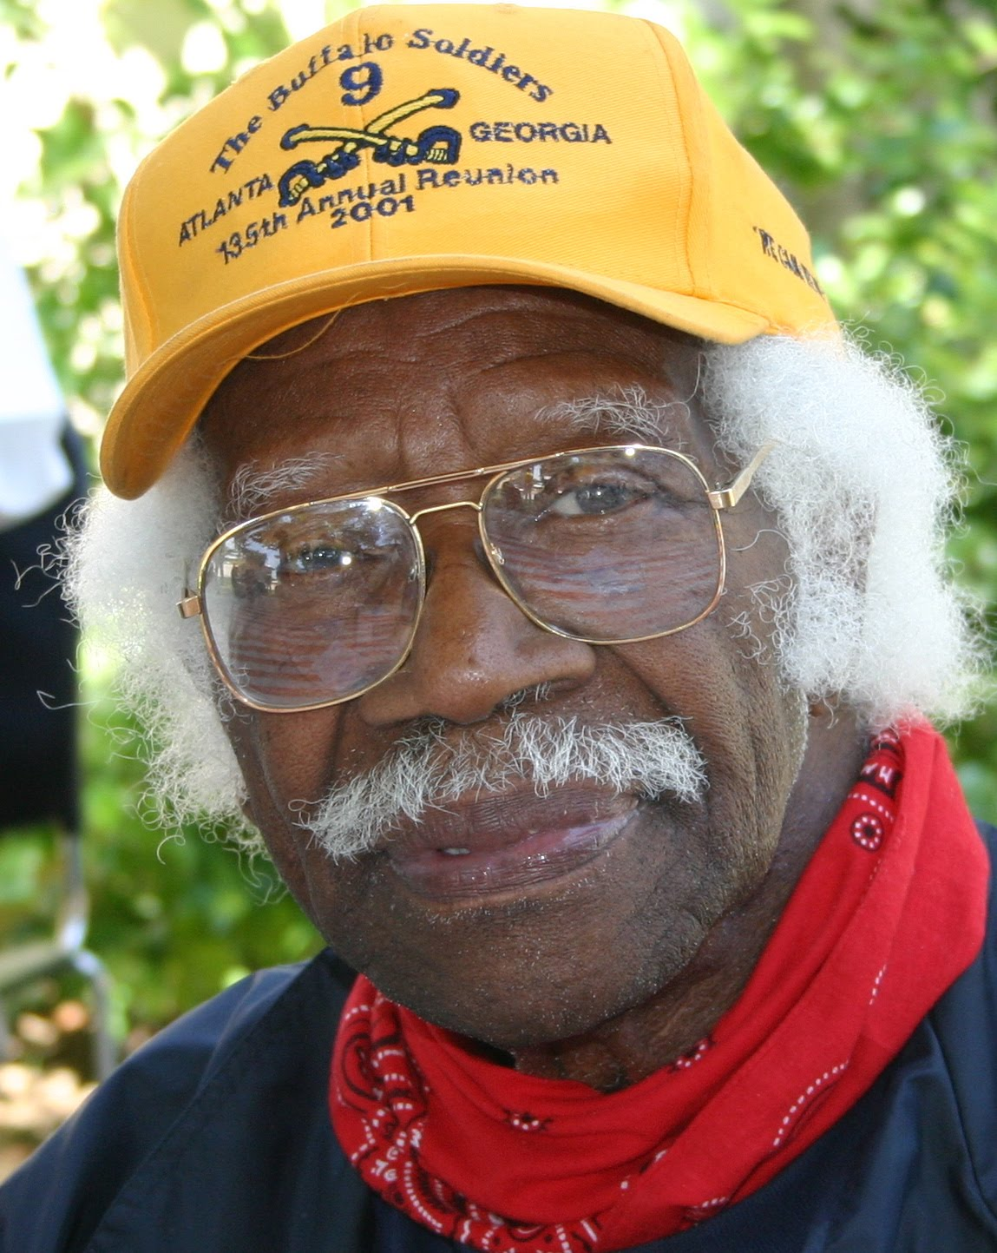
Robert L. McDaniel,
Buffalo Soldier
Another World War II Buffalo Soldier died on August 27, 2009. We as a people lost a role model and this nation lost another hero.
A role model and a hero. Think about these words; let them roll around in your mind until you’ve created a concept of understanding their definitions, their meaning and what it truly takes to be a role model and a hero. Now think of someone you know personally who is your role model or your hero. You’ll know that you have reached the correct understanding when you begin to feel a tingle that starts at the base of your neck and runs down your spine with a shiver that causes your shoulders to do the shimmy shake, and you whisper, “Oh my, I know someone like that!”
Basically, a role model is someone who is worthy of imitation. Alright, that makes sense. But how does one become worthy? Well, a worthy person is someone who has “qualities or abilities that merit recognition in some way.” Merit? How does someone merit anything? As it turns out merit is the quality of being deserving. You become deserving by your actions. In other words, you “earn” it.
Okay, we have arrived at the base word that I think we can all understand. Earn! If we do our chores we earn playtime, if we do our homework we earn good grades and if we do our job we earn a salary. There are no shortcuts to earning. You have to do the time!
A role model is someone who has done the time in such a way, that they have become deserving... they merit... they are so worthy of our respect and admiration that we view them as a Role Model.
Another Buffalo Soldier died. His name was: Trooper Robert L. McDaniel - WWII Veteran, U.S. Army - 4th Calvary Brigade, 2d Calvary Division, 9th Calvary Regiment. He was one of the few remaining original Buffalo Soldiers from a bygone era. There aren’t that many of them left. You owe it to yourself to get to know a Buffalo Soldier, before they are all gone. I knew one, and now he’s gone!
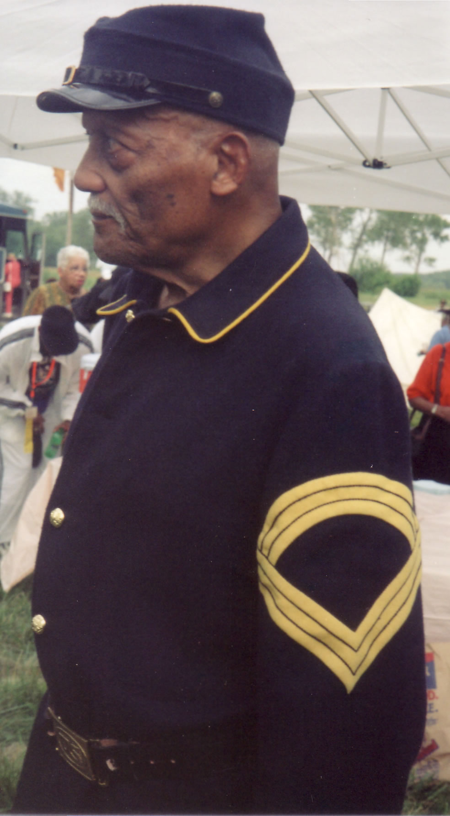
Thanks to Trooper Ron Jones from the Los Angeles Chapter of the 9th and 10th (Horse) Cavalry Association who sent this article to the Buffalo Soldiers Research Museum. His father, Trooper Fred Jones (pictured at right) was a World War II Buffalo Soldier.
(We have taken the liberty to edit the original article about Trooper R.L. McDaniels.)

Collections and More…

We have been collecting stories, photos, newspaper articles and more about the Buffalo Soldiers for more than 15 years. Our file drawers are full. What do we do with the information?

Our response: share it… give it away… tell as many people as possible about all that we have learned about these courageous veterans.

We recently published the biography of Dr. John Morton Finney, World War I Buffalo Soldier in the online version of the African American National Biography Project. This publication is housed at Harvard University under the leadership of Dr. Henry Louis Gates, Director of the W.E. B. DuBois Institute for African and African American Research. It goes lives on October 21, 2009. For more information about this project, visit http://dubois.fas.harvard.edu/african-american-national-biography-project
A subscription is required to view specific entries. For more information visit
www.oxfordaasc.com/public/

Now that fall is in the air and summer celebrations have ended, it is time to curl up on the sofa and record your story or get that stack of books and papers dusted off for more research inquiries. We are re-running information from our October 2007 issue as a reminder of possible resources for personal collections and family stories. All history is important!

~ Celebrating Your Family Health Heritage ~
Family health heritage is a record of important medical information about our ancestors and relatives. Many of the factors that determine our health or illnesses were inherited from our ancestors. Creating a family health heritage history can be beneficial in providing an assessment of our medical history. Researching and documenting family health heritage can also assist in interpreting patterns of health, illness, and genetic traits of our ancestors. Understanding our risk for developing diseases is an important reason to learn more about family health history. By knowing our risk factors, we can make informed decisions about prevention

What should be included? First, record you own medical and health facts. Then, go back one generation at a time. Record information on all family members, including the age at which they were first diagnosed, their treatment, and any surgery procedures. A comprehensive list of health conditions should include heart disease, cancer, diabetes, asthma, high blood pressure, stroke, kidney disease, learning disabilities, as well as alcoholism. On the other hand, it is vitally important to respect the privacy of all family members. This may make it difficult to get accurate information. Just beware!

Sources of information can include medical records and the recollections of living relatives. For deceased ancestors, visit your local state health department to obtain copies of death certificates. A dearth certificate will list the cause of death and the age of your relative. Other sources may include military records, family bibles, pension documents, census records, and obituaries.

One of the most important things parents can give their children is their family ancestral roots. When we understand where we came from, we can stand tall and proud. We stand on the backs of our ancestors - those who came before us who gave us the foundation to build our lives.

Our past, our stories, our health, and our future – all depend on the accuracy of the information we collect.

~ DNA Database
Helps Identify Your African Ancestry ~

African Ancestry, Inc. (www.africanancestry.com) has become the exclusive licensee of a prominent genetic researcher’s database of genetic lineages from Africa. This company, based in Washington DC, is selling DNA-based genealogy tests to anyone who wishes to genetically determine where in Africa his African ancestors came from. The test does not involve needles or blood. Laboratory scientists compare cells swabbed from the inside of your cheek with 22,000 units of genetic information (maternal and paternal lineages representing over 30 countries and 135 ethnic groups). Two tests are offered – MatriClan test of maternal DNA inherited from your mother and PatriClan test of paternal DNA inherited from your father. Each test cost $349.
This technology is being embraced by family reunions to add new information to their celebrations. Some relatives have traced the African ancestry of as many as eight of their family’s lineages. This means that they have located where all eight of their great-grandparents’ African origins began on the continent! For details call 202/723-0900 or visit their website.

Buffalo Soldiers Research Museum
P.O. Box 531187
Indianapolis, IN 46253

www.buffalosoldiersresearchmuseum.org

