www.buffalosoldiersresearchmuseum.org
Buffalo Soldiers Research Museum Newsletter
October 2006
Volume 4 - Issue 4
Published four times each year ~ January, April, July & October

The Great War

Historians call it the Great War while others call it World War 1. It began in 1914 and the United States entered the war on April 6, 1917. This war stimulated the same debate about African Americans’ participation as had previous conflicts. Within the black community, some factions argued the advantages of recognition and equality that could be achieve through military service, while others cited failures of the United States to reward blacks for their wartime service. Few whites expressed enthusiasm for black enlistees; but, once the war escalated, African Americans were welcomed into segregated units commanded mostly by white officers.
The debate among black leaders over military support began during the pre-war buildup and continued after the United States entered the conflict. Most discussions took place in public forums and did not appear in print until later. Columbia University law student, Randolph Owen, summarized the position of those who opposed black enlistments in January 1918. He wrote: “Since when has the subject of race come out of a war with it rights and privileges accorded for such participation? Did not the Negro fight in the American Revolutionary War…and come out to be miserable chattel in this country for one hundred years? Did not the Negro take part in the Spanish American War? And have not prejudice and race hate grown in this country since 1898?
The most influential spokesman supporting African American service in World War 1 was W.E.B. DuBois who argued that educated blacks had to take the lead. The “Talented Tenth” should lead the black community in support of the war. In June 1918, he concluded that these actions would result in “the right to vote and the right to work and the right to live without insult.”
Although African Americans were willing to put aside their grievances out of a sense of patriotic duty and hope for gaining further equality, white America did not rush to accept black volunteers in uniform. During the pre-war buildup of 1916, the Army recruited 650,000 volunteer soldiers but limited the number of black enlistees to 4,000; all were assigned to four Regular Army regiments serving in the Southwest (the 9th & 10th Horse Cavalries and the 24th & 25th Infantries who were called Buffalo Soldiers). When these regiments reached full strength, the Army ceased accepting black volunteers because al the new units were “white only.”
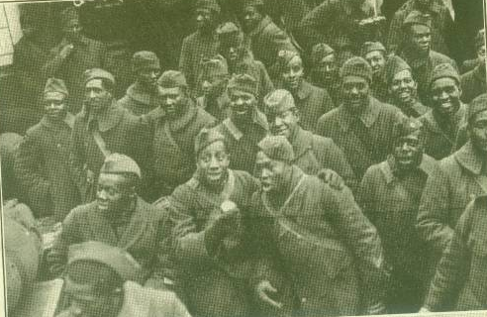
Photo taken from Scott’s Official History: American Negro in the World War

Provisions of the Selective Service Act required that every able-bodied male who was 21 years old, black or white, register for the draft. Local draft boards administered the system and reviewed the registration of each young man in their town or district for induction. Draft boards across the country recognized the chance not only to defer the white sons of the wealthy and influential but also to “rid” their communities of young African Americans. Many draft boards required black men to tear off a corner of their registration forms so that they were more readily identifiable. As a result, a disproportionate number of African Americans were drafted. During World War 1, a total of 2,291,000 black men registered for the draft (9% of all registrants). The Selective System drafted 367,710 (13%) of all black men registered.
With more than a third of a million black drafted, the War Department faced the dilemma of what to do with the new African American soldiers. Original plans to form 16 black infantry regiments quickly changed with the news of the Houston Muting in August 1917. White politicians expressed concerns about further arming and training large numbers of African Americans. As a result, the number of proposed black combat regiments was reduced from 16 to 4. The remainder of the black draftees was assigned to Service of Supplies (SOS) units and served as cooks, drivers, and laborers.
During the World War 2, Fort Des Monies hosted the formation of the first Women’s Army Auxiliary Corps (WAAC), later renamed the Women’s Army Corps (WAC). From 1942-1945, approximately 72,000 troops were trained and the first female officers for non-combat duty were commissioned here. Fort Des Monies produced 118 black female officers and 3, 656 enlisted women by war’s end, representing 4% of all WAC troops. With these two successful events, the military led the march toward racial and gender inclusion and equality throughout the greater American society.
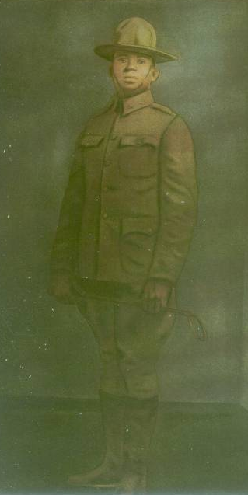
First Lieutenant Tillman H. Harpole & the Great War
American Legion Post 249 Indianapolis, IN

On June 15, 1917, the Army opened a training camp for black officer candidates at Fort Des Moines, Iowa. The first class of 639 men graduated the following October, and by the end of the war, 1,200 African Americans had earned commissions. More than 250 of the officer candidates came from the non-commissioned ranks of the four Regular Army Regiments (Buffalo Soldiers). The remaining volunteers reported from National Guards units and the civilian Talented Tenth that DuBois had encouraged to step forward.
One of the 639 officers was First Lieutenant Tillman H. Harpole who resided in from Kansas City, KS. He was born in Conway, Arkansas on March 24, 1891 and attended the Officers Training Camp at Fort Des Moines from June 24 - October 14, 1917. He did not acquire military status while at camp but was considered a civilian candidate in training for a commission. He was appointed as First Lieutenant, Infantry Section Officers Reserve Corps on October 15, 1917. He entered active duty and served with Company M, 372nd Infantry at Camp Funston, Kansas.
Camp Funston, Kansas was named after Major General Frederick Funston and was established as one of 16 Divisional Cantonment Training Camps during WWI. The Second Cavalry Division, the Cavalry School, and the Cavalry Replacement Training Center were stationed at Camp Funston and Fort Riley. Construction of the 2,000 acre camp began during the summer of 1917 and eventually encompassed 1,400 buildings. During World War I, nearly 50,000 recruits trained at Camp Funston. The 10th Division and black soldiers assigned to the 92nd Division received their basic training at the camp, also.
Later, First Lieutenant Harpole was sent to Camp Stuart, Virginia. On March 30, 1918, he left the United States for combat service overseas. With the 372nd Infantry, he served in the Air Defense sector and participated in the Meuse-Argonne Offensive. Harpole was killed in action on October 5, 1918 in the Meuse Argonne offensive. The name and address of his nearest relative was Mary C. Harpole, wife, Phoebus, Virginia.

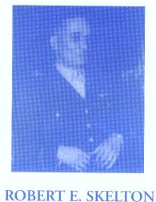
In Honor of a Fallen American Hero
On July 9, 1936, a group of 15 World War 1, African American veterans finalized the organization of the Lt. Tillman H. Harpole American Legion Post 249 in Indianapolis, IN. Robert E. Skelton was the founder and was elected as the post’s first commander in 1936. He served six terms. The Post applied for a charter on July 21, 1936 and was granted the charter January 21, 1937.
Dedicated officers and a core of active members generated a substantial membership over a short period. They earned the Floyd L. Young Membership Trophy for the largest gain in members among all posts in Indiana. Tillman H. Harpole Drum and Bugle Corps, organized in 1937, drew national attention and placed third in state competition. Its Color Guard was judged State Champions in 1939, and its marching unit was the pride of Indianapolis. The first post home was purchased at 2523 Northwestern Avenue (now Dr. Martin Luther King, Jr. Street) in 1938.
On April 17-19, 1998 the Lt. Tillman H. Harpole American Legion Post 249 made another milestone in its long history – the dedication of a new building at the same location. The City of Indianapolis and Mayor Stephen Goldsmith made a proclamation that April 17-19 was “America Legion Day.”
The American Legion organization was founded in 1919 during a caucus in Paris, France, which was attended by representatives of various outfits of the American Expeditionary Forces of World War I. This venerable organization now includes veterans of all wars and conflicts.

Reflections
In November 2004, Trevor Bacon, Lt. Tillman H. Harpole American Legion Post 249 Commander appointed their first curator of collections. The post had a large collection of photographs, historical documents, and artifacts that needed to be cataloged and preserved. Bacon took the leadership to ensure that information and materials from those World War I veterans was preserved for future generations. As the curator, I began to study the Great War and got a better understanding of the role that African Americans played in that conflict.
I visited Kansas City, Kansas where the only major museum in the United States dedicated to the study of the Great War is located. During my research, I discovered a book written by a black man, entitled American Negro in the World War by Emmett J. Scott, who was Special Assistant to the Secretary of War copyrighted in 1919. Scott also authored Tuskegee and Its People and Is Liberia Worth Saving? He also co-authored Booker T. Washington: Builder of a Civilization. Scott served as Secretary of Tuskegee Normal and Industrial Institute for eighteen years as the private secretary to Booker T. Washington.
A special thanks goes to Averitte W. Corley, a WWII Montford Point Marine who provided a signed copy of the American Negro in The World War. It’s a great resource!
George Hicks, III
Curator, American Legion Post 249 and the Buffalo Soldiers Research Museum,

Sources:
Buffalo Soldiers Research Museum @ www.buffalosoldiersresearchmuseum.org.

Cole, H.S. and Henderson, F.J. (eds.)(1995). Historical and Pictorial Review: Second
Cavalry Division, United States Army Camp Funston, Kansas 1941.

Fort Des Monies Museum and Education Center: 75 East Army Post Road-Des Monies,
Iowa 50315. (515) 828-8060 – 1-888-828-Post.

Hicks, G. III. (2005). The History of Lt. Tillman H. Harpole American Legion Post 249,
Indianapolis, IN.

Scott, E.J. (1919) Scott’s Official History: American Negro in the World War,
Washington DC.

Another Resource about the Buffalo Soldiers
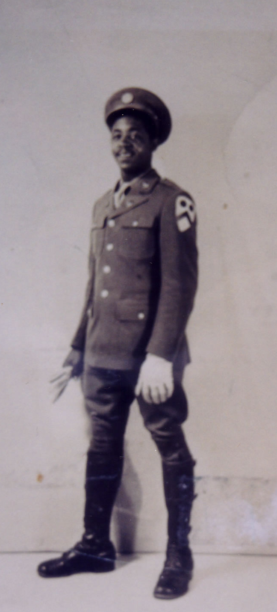
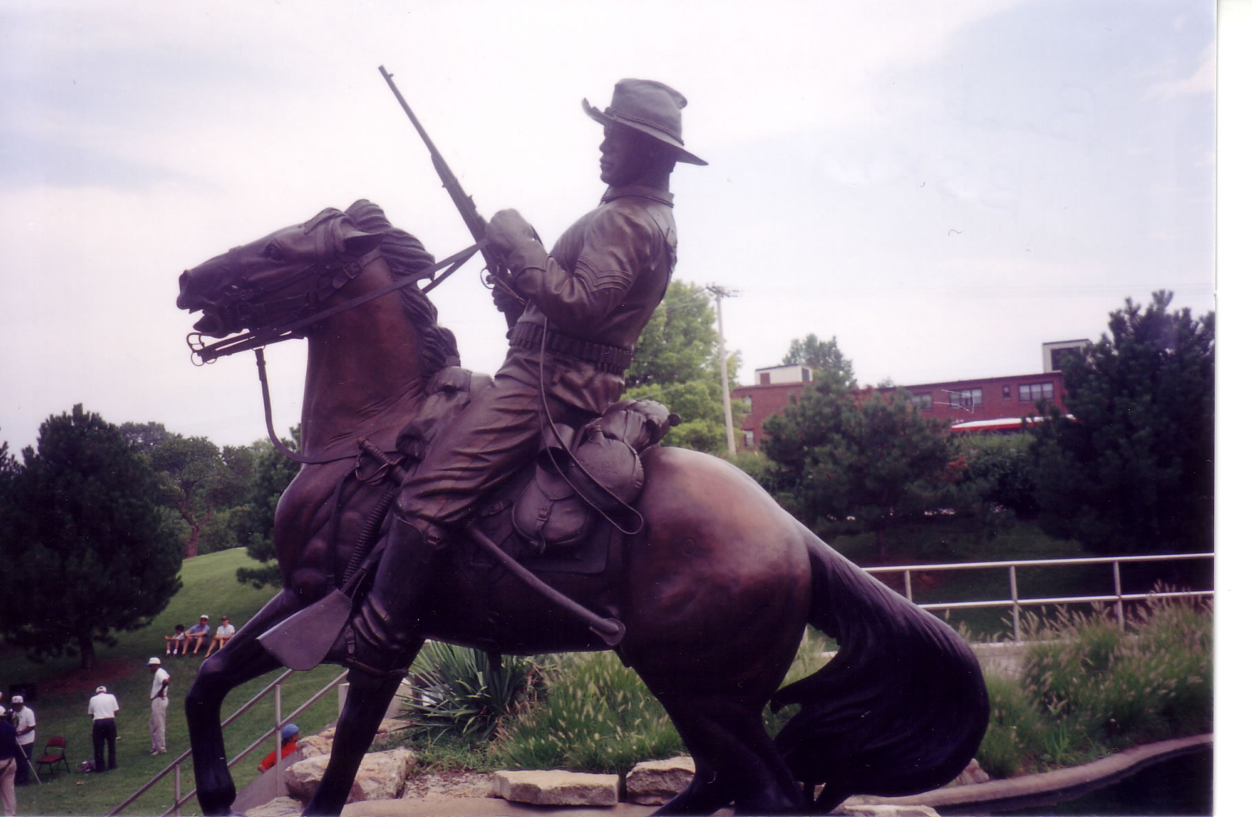
Our Journey with the Buffalo Soldiers is a compilation of historical research, travel adventures, family histories, and personal stories. African American military units were established in 1866 and these soldiers had much to prove. They earned the name “Buffalo Soldiers” from Indians who held their fighting spirit in high regard. Over the years, they served in all of the military conflicts - the Indian Wars, the Spanish-American War, World War I and World War II. Stories of racial prejudice are peppered throughout their history. During World War II, the Army mechanized their equipment and these units were disbanded.

This journey focuses on the stories of World War II soldiers but a historical perspective is provided to lay the foundation for these stories. Information about Lt. Henry O. Flipper, the first African American graduate from the West Point Military Academy and other historical military figures are included. Each story is situated by its location and is part of the “journey.” The stories about the World War II soldiers are personal and touching. Some described how they were afraid of horses but learned to ride, clean and feed them. There are more stories about traveling by train across the US, living on a ship going across the Atlantic Ocean, experiencing a accident in a jeep during the European Theater, leaving the Army and joining the Air Force, and life events after World War II. Many men returned “home” and took advantage of the GI Bill or settled into stable government jobs.
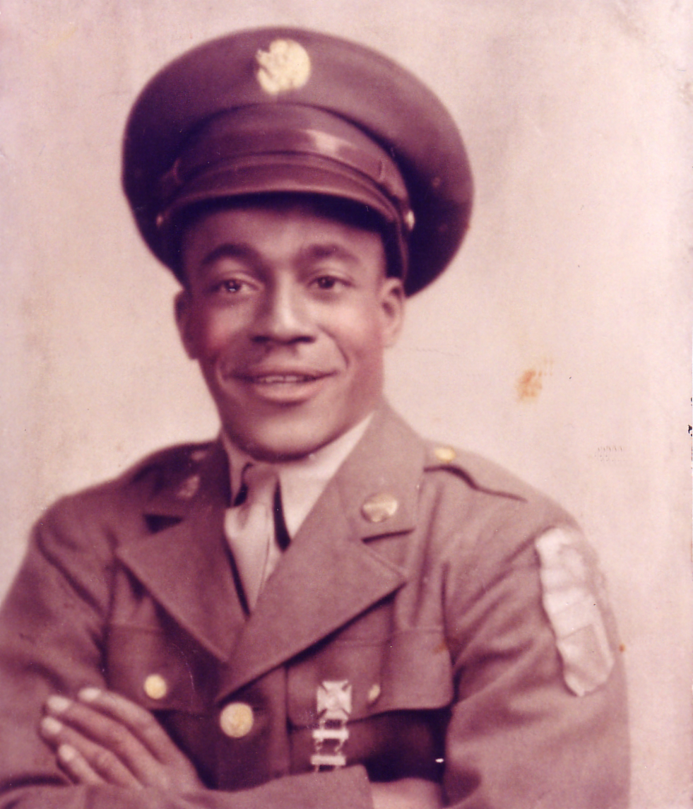
Photographs and interviews with Buffalo Soldiers who attended the reunions of the Buffalo Soldiers every July add a special touch. City by city and fort by fort – personal stories are connected to each location. From Thomasville, GA to Portland, OR the Buffalo Soldiers have many stories to share.

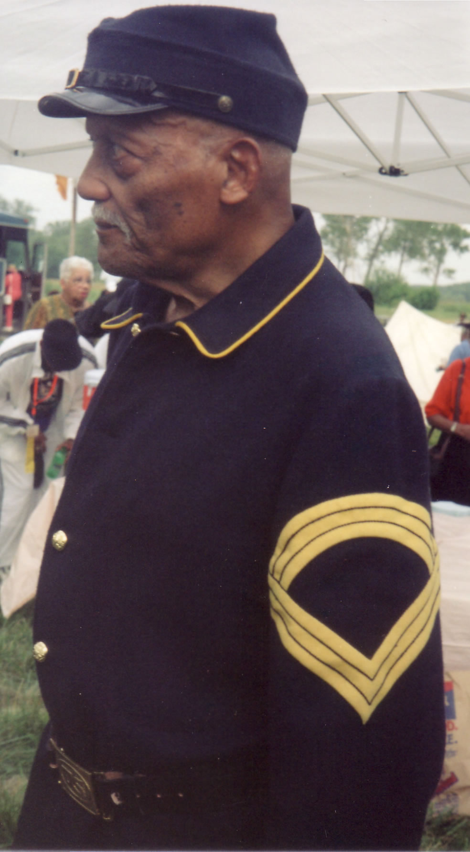
George Hicks III wrote - I get excited when I read stories about African American men who served in the U. S. Army as infantryman and cavalryman. These soldiers - Buffalo Soldiers - were my ancestors. I grew up in the 1950s-1960s, watching westerns movies, and I never saw black men riding horses nor as soldiers in the all-white U. S. cavalry regiments. Not until the 1980s when the stories of black soldiers were covered in the media did I revisit my childhood and ask questions. The Buffalo Soldiers were mistreated, issued inferior clothing and equipment, and received less compensation for their effort. They were assigned to military posts far from their families and the townspeople because the same people that they were to protect did not like the color of their skin. They endured the storms and I am so very proud of my black brothers.

I have visited places where they served – Washington DC, California, Virginia, Arizona, Mexico, Washington, Oregon, and Kansas and lived in their hometowns. I interviewed troopers who served in the 9th, 10th, 27th, and 28th (Horse) Cavalry regiments. The landscape where they served even today looks rough, hot, and uncomfortable. If they could do what they did under those conditions servicing this country. Surely I can sit in the comforts of my home and write about what I discovered about my ancestors.

I decided to tell what I am learning about these men and women. Yes, there was at least one documented female Buffalo Soldier - Cathy Williams. It feels good to write positive stories about us. Perhaps there are other positive stories that need to be written. If you discover a subject that inspires you, sit down and start writing for future generations. It is our history. When you know your past, you can better understand your present and prepare for the future.

Carmon Weaver Hicks wrote - George led most of the journey. When you read a section that starts with “I,” the “I” is George. For many sections, the pronoun is “we.” We learned so much, worked so hard, and feel so good about our efforts. This journey has been George’s mission but you know the old saying: Behind every good man is his woman. Well¸ I followed him everywhere on this journey and cheered him along the way. Occasionally, I led us to new research, new places, and sometimes backtracked to places we had been before. The old soldiers that we met and learned so much from are dying everyday; nevertheless, we savored each moment. We hope you will, too.

(Photos – Buffalo Soldiers’ National Monument, Ft. Leavenworth, KS; Troopers William Snow, 1940s;
Lorenzo Denson 1940s and Fred D. Jones, 2001)

To purchase Our Journey with the Buffalo Soldiers, visit www.xlibris.com
www.amazon.com
www.barnesandnoble.com

Buffalo Soldiers Research Museum
P.O. Box 531187
Indianapolis, IN 46253

www.buffalosoldiersresearchmuseum.org

