www.buffalosoldiersresearchmuseum.org
_______________________________________________________________________________________________________________
Buffalo Soldiers Research Museum Newsletter
January 2010
Volume 8 - Issue 1
Published four times each year ~ January, April, July & October

His Stories Updates
We continue to collect local stories about military histories. A few recent updates are included here as well as the latest news honoring Pearl Harbor hero - Dorie Miller, US Navy.
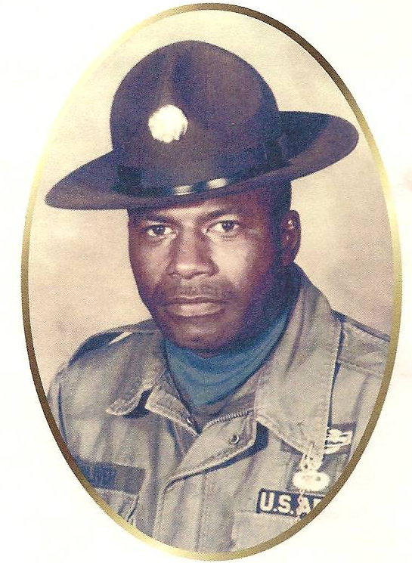
Howard Claude Oliver (1930-2009)

Howard C. Oliver was born in Drakesborough, KY on December 13, 1930 to Willie C. Oliver and Mary Caldwell Oliver.

He retired Sergeant First Class (E-7) from the U.S. Army, a veteran of the Korean and Viet Nam Wars. He served as an Airborne Ranger and in the Special Forces and was awarded the Bronze Star for valor and two Purple Hearts. In 1963, as part of the Special Forces, he stood at the graveside service of President John F. Kennedy.

Oliver also retired from the Washington State Department of Fisheries where he earned his Open Water Scuba Certification and Pilot’s License. He received his Bachelor of Science degree in Marine Biology. Oliver was an associate member of the Tillman H. Harpole American Legion Post 249.

In 1956, Oliver was united in marriage to Nobuko Maruta and together they had three sons. On August 20, 2009, after a long battle with lung cancer, he joined his wife of 46 years in eternal rest at Arlington National Cemetery in Arlington, Virginia.
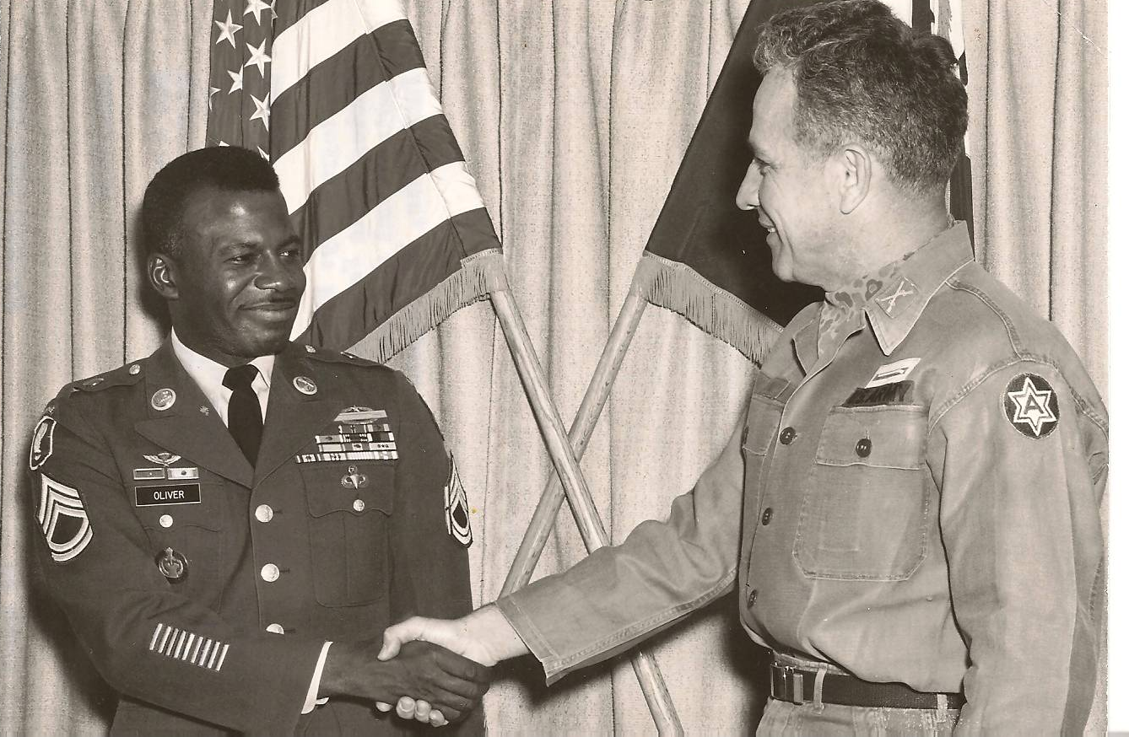

Oliver’s promotion to Sergeant First Class
Fort Lewis, April 16, 1969

Command Chief MSGT Richard Lawrence
U.S. Air Force

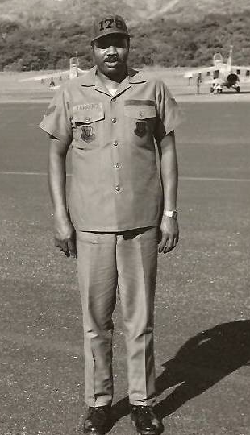
Richard Lawrence enlisted in the US Air Force on November 3, 1961. After basic training, he was stationed at Sembach Air Force Base, Germany on May 5, 1962 in support of the Viet Nam War. He returned to the U.S. on May 5, 1965 and served in the U.S. Air Force Reserves until November 3, 1967 when he was honorably discharged.

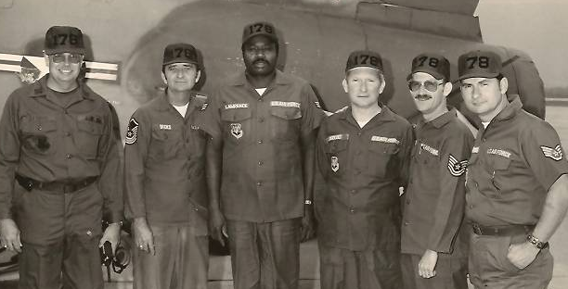

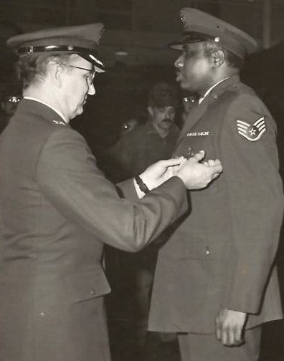
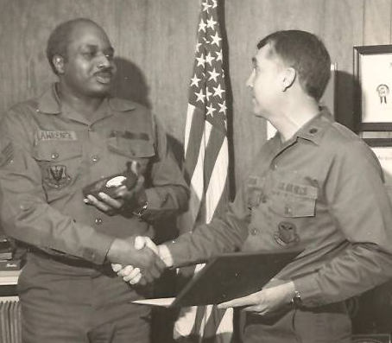

Lawrence enlisted in the Air Force National Guard in Springfield, Ohio in 1977 and was assigned to the 178 TAC Fighter Base. He supported Desert Storm in 1990 and was honorably discharged on January 15, 2001 with the rank of Command Chief Master Sergeant.

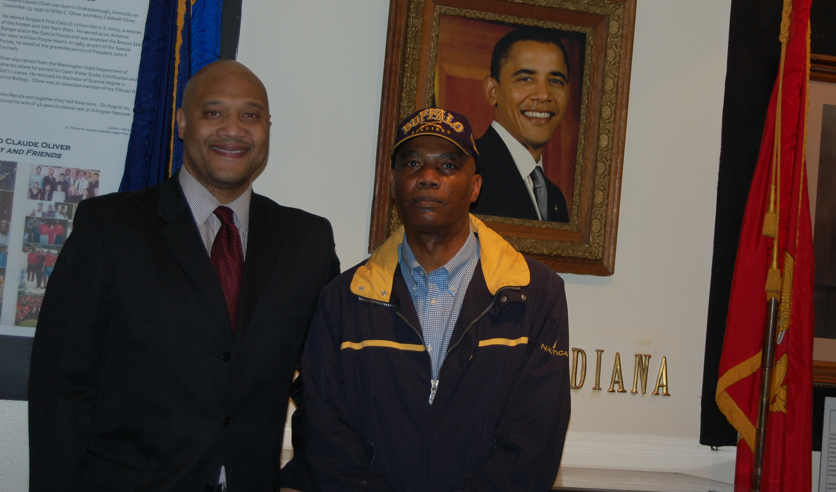

Congressman Andre Carson with George Hicks, III

Carson takes a moment to view the historical and military exhibits developed by the curator of the Buffalo Soldiers Research Museum. This outreach program is in collaboration with the American Legion Post 249 in Indianapolis, IN. The Post’s historical photos and materials are documented. African American military history is preserved for future generations.
November 2009

William Harvey
U.S. Navy Veteran and Pearl Harbor Survivor

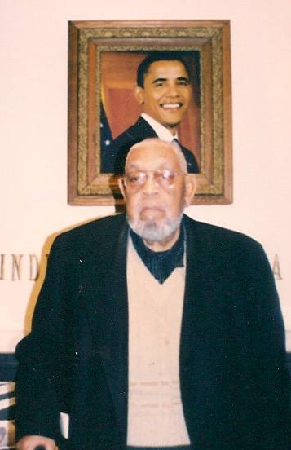
William Harvey was aboard the USS Sacramento when bombs attacked Pearl Harbor on December 7, 1942. Members from the Tillman H. Harpole American Legion Post 249 conducted a memorial service at White River, Indianapolis. More than 2,400 soldiers lost their lives at Pearl Harbor.

Harvey entered the Navy at Heslar Naval Armory in 1938. Most of the men on the USS Sacramento were from Indiana. At Pearl Harbor, that Sunday morning around 8 am – he heard the planes coming in and noticed the big red sun on the side of the Japanese planes. The Navy crew broke into the ammunition locker and armed themselves. He and other shipmen fired on the planes as they crossed from “battleship row” after dropping their munitions. They continued to fight using rifles from WWI. Reports later noted that Lieutenant Commander F.F. Knachel, officers and crew were cool and deliberate and the conduct of all exemplary. The day lives on in infamy….

Dorie Miller, U.S. Navy Update

Congresswoman Eddie Bernice Johnson, Texas (D) introduced House Bill 4851 requesting that Dorie Miller, U.S. Navy be posthumously awarded the Congressional Medal of Honor. Her efforts continue. For additional information, contact her office – (202) 225-8885 or www.ebjohnson.house.gov

Efforts are underway for a commemorative U.S. postal stamp honoring Dorie Miller. To sign the petition, visit www.ipetitions.com/petition/WWIIHEROSTAMP/signatures.html

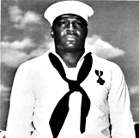
For more information about Dorie Miller and other soldiers, visit www.buffalosoldiersresearchmuseum.org

For more information about the Buffalo Soldiers and other
African American soldiers, contact the

Buffalo Soldiers Research Museum
P.O. Box 531187
Indianapolis, IN 46253-1187
georgehicks@comcast.net
www.buffalosoldiersresearchmuseum.org

