www.buffalosoldiersresearchmuseum.org
Buffalo Soldiers Research Museum Newsletter
January 2009
Volume 7 - Issue 1
Published four times each year ~ January, April, July & October

Remembering African American Korean War Veterans

Fifty-five years ago, the Korean War came to an uneasy end. After two years of negotiations, American, South Korean, North Korean and Chinese Communist delegates signed an armistice on July 25, 1953. The war had lasted three years and one month and cost the lives of over a million people, including 36,516 Americans.

The Korean War - the first “hot” conflict of the Cold War - saw Democratic countries under a United Nations mandate fight for freedom against Communist forces in a war that constantly threatened to become a global conflict. Yet, it is known today as America’s “Forgotten War.”

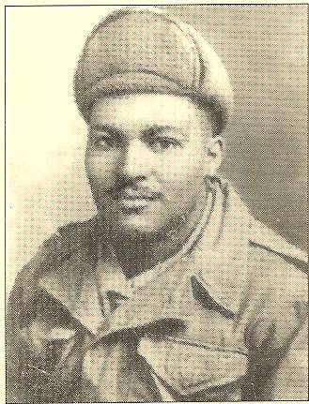
In November 2008, Bob Gumbs from New York City mailed an invitation to the Buffalo Soldiers Research Museum. Gumbs and a group of friends discovered a small park in the Bronx. They noticed a plaque with the name of a Korean War soldier who had won the Medal of Honor. The small park was in bad condition. After researching this American hero, the group established the Friends of Charlton Garden. They raised funds to improve the park - to date they have more than one million dollars for this project. Further research discovered that the plaque was mounted for Sergeant Cornelius H. Charlton who served in the 24th United States Infantry Regiment. This regiment was composed of all African Americans soldiers - nicknamed the Buffalo Soldiers.

Sergeant Cornelius H. Charlton
Cornelius H. Charlton was born on July 24, 1929 in East Gulf, West Virginia to Van and Clara Charlton. In 1944, the family moved to the Bronx, New York. Cornelius attended James Monroe High School. After graduation, he enlisted in the U.S. Army in 1946. He was initially assigned to an engineering group but Charlton requested a transfer to an Infantry unit and was placed in Company C of the 24th Infantry Regiment, 25th Infantry Division. The 24th Infantry nicknamed the “Buffalo Soldiers” was the last all-black unit in the U.S. Army. Earlier, in 1944, the horse units of the Buffalo Soldiers – the 9th, 10th, 27th and 28th Cavalries were deactivated.

On June 2, 1951, near the village of Chipo-ri, northeast of Seoul, Korea, Sgt. Charlton’s platoon encountered heavy resistance while attempting to take Hill 543. Taking command after his platoon leader was wounded; he regrouped his men and assumed command, rallied the men, and spearheaded the assault against the hill. Personally eliminating two hostile positions and killing six of the enemy with his rifle fire and grenades, he continued up the slope until the unit suffered heavy casualties and became pinned down. Regrouping the men, he led them forward only to be again hurled back by a shower of grenades. Despite a severe chest wound, Sgt. Charlton refused medical attention and led a third daring charge which extended to the crest of the ridge. Observing that the remaining emplacement which had slowed the advance was situated on the reverse slope, he charged it alone. He single-handedly attacked and disabled the last remaining enemy gun emplacement, suffering another grenade wound in the process. Sgt. Charlton succumbed to his wounds that day, dying at the age of 21. His courage, leadership and gallant self sacrifice reflect the highest credit for himself, the infantry, and the military service. For his actions during the battle, he was posthumously awarded the Medal of Honor and the Purple Heart on February 12, 1952.

Sergeant Charlton’s body was returned to the United States where he was buried in his mother’s family burial place in West Virginia. According to family members and other veterans, Sgt. Charlton was not buried at Arlington National Cemetery because of his race. In 1989, the Medal of Honor Society discovered Sgt. Charlton burial site in poor condition and in 1990 re-interred his remains at the American Legion Cemetery in Beckley, West Virginia.

Several memorials were named in Sgt. Charlton’s honor - a park: Charlton Garden and a ferry boat that traveled to Governor’s Island in the Upper New York Bay: US Army Sgt. Cornelius H. Charlton, a bridge: the C.H. Charlton Memorial Bridge on Interstate 77 in West Virginia, and an Army barracks complex in South Korea. In 1958, trees were planted in Van Cortlandt Park in the Bronx in his honor. And in 1999, the US Navy named a supply ship, USNS Charlton (T-AKR-314) after Sgt. Charlton.

The Invitation
The Family of Sergeant Cornelius H. Charlton
And the Friends of Charlton Garden
Invite you to attend the Re-Interment Ceremony of
Korean War Medal of Honor Recipient
Sergeant Cornelius H. Charlton

Wednesday November 12, 2008 at 11 AM
Arlington National Cemetery
Arlington, Virginia

A reception will follow the ceremony
The Fort Myer’s Officers Club

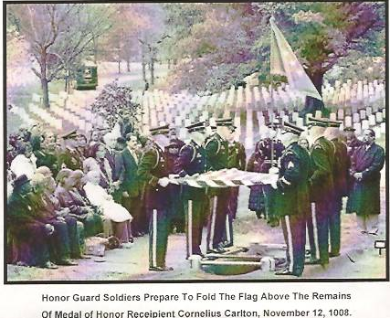

Cornelius Charlton’s long journey that began on Hill 543 in Korea more than half a century ago and took him through burial grounds in two Virginias finally ended on November 12, 2008. Many friends and family members, including his sister Fairy Mae Papadopoulos (pictured in the wheelchair), were there to celebrate and honor Sgt. Charlton.

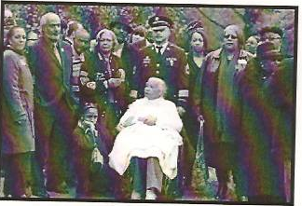
Background
The Medal of Honor
The Medal of Honor is the nation’s pre-eminent award for military valor. It was the first decoration officially authorized by the government as a badge of honor by President Abraham Lincoln in 1862. The honor was presented to enlisted soldiers who “shall distinguish themselves by their gallantry in action and other soldier-like qualities.” They were the target of bullets, mortars and grenades. They stepped into the line of fire to save their comrades. Many suffered devastating injuries. Most died. They are America’s greatest heroes. The recipients include only 3, 448 of the millions of men and women who have served this country since the Civil War. As a symbol of heroism, it has no equal in American life.

There are three different types of Medal of Honor. The original star-shaped design of the medal established in 1861 featured an allegory of the Union - carrying a shield in her right hand and repelling an attacker, crouched alongside the fork-tongued serpents that struck at the shield. In her hand, the Union held the ancient Roman shield of government authority - the fasces. The 34 stars around the figures represent the number of states at that time. The reverse was left blank for engraving the recipient name, the date, and the place of the act of bravery for which the medal was awarded. The Navy, Marine Corps, and the Coast Guard have retained this design. The Army designed a wreath version in 1904 and the Air Force altered the wreath in 1963.

Of the 3,448 recipients, 19 soldiers received the medal twice. Of these 19 soldiers, 14 received two separate medals for two separate actions. One African American earned two Medals of Honor – Robert Augustus Sweeney, US Navy earned two awards for separate actions. Five men received both the Navy and Army Medal of Honor for their action. One woman has received the Medal. The Army has awarded 2,402; the Navy awarded 747; the Marines awarded 297; the Air Force awarded 17; the Coast Guard awarded one, and there are nine unknown awards.

On April 6, 1865, 12 soldiers became the first African Americans to receive the medal. They were members of the five regiments of the U.S Colored Troops who fought at New Market Heights (seven miles from Richmond, Virginia). They charged 300 yards across open fields into heavy Confederate fire, rescuing comrades and proving their ability to fight for their country. Currently, a total of 88 African American soldiers from all branches of the military have earned this medal.

More specifically, a total of 24 Buffalo Soldiers earned the Medal of Honor. The book Black Valor: Buffalo Soldiers and the Medal of Honor, 1870-1898 by Frank Schubert brings the lives of these brave soldiers into sharp focus.

Reflections
My wife (Carmon) and I, here at the Buffalo Soldiers Research Museum, were grateful for the invitation to attend the ceremony for Sergeant Cornelius H. Charlton at Arlington National Cemetery on Wednesday, November 12, 2008. Thanks to Mr. Bob Gumbs and the “Friends of Charlton Garden” for their effort. They continue to give their time and resources to ensure that Sergeant Charlton’s contributions and his story would not go untold. Today is the 25th of December and I am still receiving email attachments from various newspapers about his story.
If you have information about other African American soldiers, sailors, airmen, or Marines who have stories that have not been documented, please contact our small, private not-for-profit museum. We want to record our stories…

MSG George Hicks, III (Retired)
US Army
Curator, BSRM

Credits
Bowers, W.T., Hammond, W.M., and MacGarrigle, G.L. (1996). Black soldier - white army:
The 24th infantry regiment in Korea. Washington DC: Center of Military History,
United States Army.

Bob Gumbs and the Friends of Charlton Garden
2541 Adam C. Powell, Jr., Building 13F, New York, NY 10039
RAGUMB@AOL.COM, personal communications (Fall 2008).

Schubert, F. (1997). Black Valor: Buffalo Soldiers and the Medal of Honor, 1870-1898.
Wilmington, DE: Scholarly Resources Books.

The Salute! US Army. (Fall 2008). PO Box 529, Shawnee Mission, KS.
www.FreedomTeamSalute.com

www.arlingtoncemetery.net/chcharlton.htm Retrieved on November 17, 2008.

www.history.army.mil/html/moh Retrieved January 1, 2009.

www.homeofheroes.com Retrieved January 1, 2009.

For more information about the Buffalo Soldiers
and other African American soldiers, contact the

Buffalo Soldiers Research Museum
P.O. Box 531187
Indianapolis, IN 46253-1187

www.buffalosoldiersresearhmuseum.org

